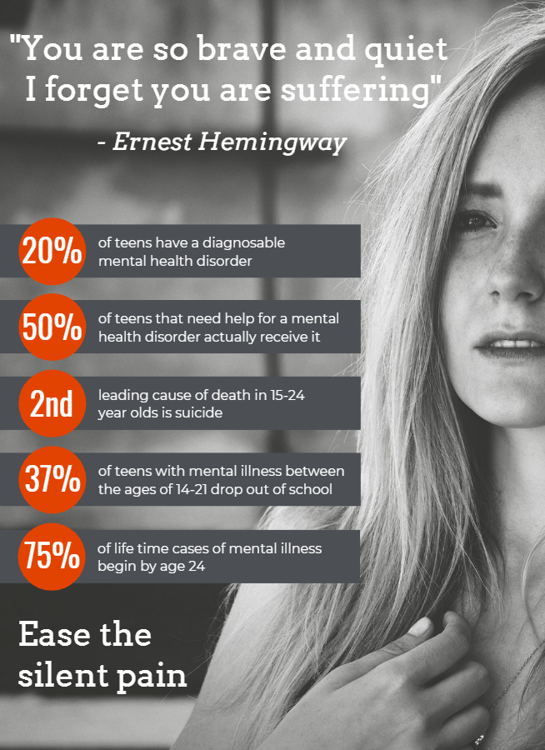

Do you know someone who has suffered in silence?

Mental illness doesn’t discriminate. One in five teens suffers from a mental disorder severe enough to impact their daily activities. Thanks to your investment, thousands of youth have found the strength they need to overcome these challenges and look forward to their future. Here’s what some of our clients have to say about the impact of your support:

“I did not feel judged and that helped my anxiety. Thank you!”
"Epworth has gone above and beyond to make sure I met my set goals. My case manager is super encouraging, understanding, and helpful.”
“I’m very proud of how much change I have made.”
This year there are 13,000 new success stories waiting to happen. You and your donation will help youth who are suffering discover the peace, strength, and skills to grow towards self-sufficiency. Please make your donation today and continue to help those who put on a brave face but suffer silently.

Thank you for all you do.
Michelle D. Tucker
President and Chief Executive Officer

