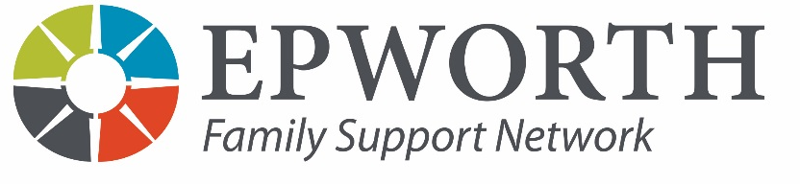
110 N. Elm St. Louis, MO 63119
Main phone# 314-918-3301
Intake Coordinator# 314-918-3362
Fax: 314-918-3395

REFERRAL FORM
*Race: Asian, Bi-Racial or Multi-Racial, Black or African American, Native American or Alaska Native, Native Hawaiian or Other Pacific Islander, White or Caucasian, Decline to Disclose
**Ethnicity: Afghani, Albanian, Arab Bosnian, Congolese, Croatian, Hispanic/Latino, Iraqi, Roma, Serbian, Somali, Syrian, Vietnamese
Parent/Guardian Name: Birth date: Race*:
Ethnicity**: Gender: FSN Use:
Case Number:

Address: ZIP: St. Louis City St. Louis County
St. Charles County
Home Phone: Work Phone: Cell/Other Phone:
Household Income: This information is gathered solely to meet agency funder requirements and does not affect service eligibility or delivery.
Please check the range that best represents current household income.

___ $0-9,999 ___ $10,000-14,999 ___ $15,000-19,999 ___ $20,000-29,999 ___ $30-49,999 ___ $50,000-99,999 ___ $100,000 or more
Client Email: | Current/Former Epworth client/student? Yes No
Preferred Language: English Spanish Other ______________________ Communication Assistance Required?
Days / Times available: School District:
Children / Others in household:
Name Relationship (to above) Birthdate Gender Race* Ethnicity ** FSN ID #

1. ______________________________________________________________________________________________________________________

2. ______________________________________________________________________________________________________________________

3. ______________________________________________________________________________________________________________________

4. ______________________________________________________________________________________________________________________

5. ______________________________________________________________________________________________________________________

6. ______________________________________________________________________________________________________________________

Briefly describe current situation: __________________________________________________________________________________________

_________________________________________________________________________________________________________________________

_________________________________________________________________________________________________________________________

_________________________________________________________________________________________________________________________

_________________________________________________________________________________________________________________________

_________________________________________________________________________________________________________________________

Please indicate if any family member has an Autism, Cerebral Palsy, Epilepsy, Learning Disability or Mental Retardation diagnosis.
Name SS# Diagnosis Regional Center or City Office for DD Resources?

_________________________________________________________________________________________________________________________

_________________________________________________________________________________________________________________________

Please check all factors that are present at time of referral:

Child/Youth Characteristics: ___ Infant (birth-1) ___ Young Child (1 to 4) ___ Child with Behavior Problems

___ Child w/ MR/Disability/Chronic Illness ___ Child with Trauma History ___ Child w/ Mental Illness

Parent Characteristics: ___ Teen Parent ___ Single Parent ___ Parent w/ History of Abuse

___ Poor Parenting Skills or Harsh Discipline ___ Parent with Mental Illness ___ Parent with MR/Disability

___ Parent with history of Substance Abuse ___ Parent with history of Domestic Violence

___ Parent with Education Under 12 Yrs.

Family Characteristics: ___ Financial Challenges ___ Unemployment ___ Paramour in Home ___ Lack of Support System

___ Homeless or Poor Living Conditions ___ History of Hotline Calls

Other Important Characteristics (Please List): ________________________________________________________________________________

________________________________________________________________________________________________________________________

________________________________________________________________________________________________________________________

What other services is the family receiving? ________________________________________________________________________________

Referral Source:

Agency / Organization:

Contact Number: E-Mail:

How you heard about FSN? ____________________________________________________________________________________________

REMAINDER OF FORM FOR FSN USE ONLY:
Waiting list time indicated at time of referral? _______________________________________________________________________________

Resources given out, if appropriate _______________________________________________________________________________________

Date Referral Received: Start-End Time:

Intake Date:
Case #: __________________________________________________ Funder:_________________________________________________
Therapist assigned: Date assigned:

